Project Documentation

PROJECT TITLE: SpendWise – A Simple Backend Learning Project using Node.js, Express, MongoDB, and JWT

1. INTRODUCTION:
• Project Title: SpendWise – A Simple Backend Learning Project using Node.js, Express, MongoDB, and JWT
• Team ID : SWTID-2026-2148
• Team Leader: ASHA.A – 202400940@sigc.edu
• Team Members:
● Aishwarya V – 202400774@sigc.edu
● Anugraha SS – 202400939@sigc.edu
● Ashika T – 202400923@sigc.edu

2. PROJECT OVERVIEW:
SpendWise is a backend application designed to assist novice developers in learning how to construct secure RESTful APIs utilizing Node.js, Express, MongoDB, and JWT authentication.
This project focuses on the implementation of user authentication and fundamental CRUD operations in a clear and uncomplicated way, enabling students to grasp how backend systems operate in practical applications.

3. KEY OBJECTIVES:
- Establish secure user authentication utilizing JWT (JSON Web Tokens).
- Facilitate fundamental CRUD operations for the administration of user data, including transactions and records.
- Exhibit MongoDB integration via Mongoose to ensure effective data modeling and interaction with the database.
- Showcase the implementation of protected routes through the use of authentication middleware.
- Preserve a straightforward, organized, and beginner-friendly backend architecture to enhance learning and comprehension.

4. TARGET USERS:
- Beginner backend developers who want to understand how server-side applications work.
- Students learning Node.js and Express as part of their web development journey.
- Freshers preparing for technical interviews who need practical backend project experience.
- Anyone looking for a simple project to understand JWT authentication and MongoDB integration.
- Learners who want hands-on practice building RESTful APIs.

5. PROJECT INSTRUCTIONS:
- SpendWise is a backend-only project built using Node.js and Express.
- Quick Start:
- npm init
- npm install
- npm run dev

6. STEPS TO CREATE THE PROJECT:
- Select or create a directory where the backend project will be stored.
- Open the terminal and navigate to the project directory.
- Initialize a Node.js project by running npm init.
- Install the required dependencies such as express, mongoose, jsonwebtoken, bcrypt, cors, and dotenv.
- Create the necessary project folders: models, routes, controllers, middleware, and config.
- Start the development server using the command npm run dev.
- Test the API endpoints using Postman or Thunder Client at http://localhost:5000.

7. PRE-REQUISITES:
Software Requirements
- JavaScript (ES6+) for modern JavaScript features and syntax
- Node.js and Express.js for building the backend server and APIs
- MongoDB with Mongoose for database management and data modeling
- JWT authentication for securing user login
- Basic REST API concepts for handling HTTP requests and responses
- Git basics for version control and code management.

8. THUMBNAIL FOR PROJECT:
- Node.js logo
- Express.js text/logo
- MongoDB leaf logo
- JWT token / lock icon (to represent authentication)
- CRUD icons (Create, Read, Update, Delete arrows or database symbols)
- Server / database illustration

9. PROJECT ARCHITECTURE IMAGE:

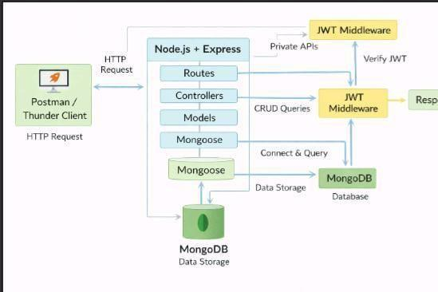

10. BACKEND DEVELOPMENT:
- Controllers: Manage business logic for user authentication and CRUD operations
- Models: Define Mongoose schemas for User and Transaction entities
- Routes: Set up API endpoints for authentication and CRUD functionality
- Middleware: Implement JWT verification to secure and protect routes
- Configuration: Handle database connections and manage environment variables

11. DATABASE ARCHITECTURE (MongoDB)
- Users Collection:
  - Fields: _id, name, email, password (hashed), createdAt

- Transactions Collection:
  - Fields: _id, userId (foreign key), title/description, amount/value, createdAt
- Relationship:
  - Each user can have multiple transactions (One-to-Many relationship)

12. ER DIAGRAM:
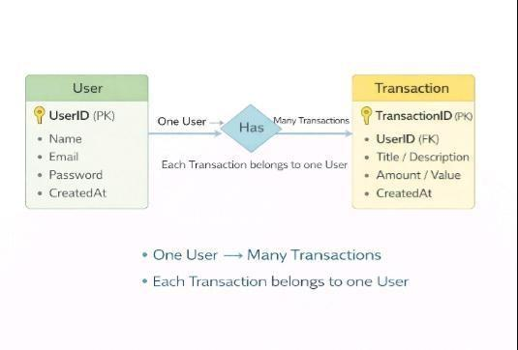

13. FEATURES:
- User Authentication Registration and login using JWT-based security
- CRUD Operations Perform Create, Read, Update, and Delete actions on transactions
- Protected Routes Secure API endpoints with JWT.
- MongoDB Integration Manage data storage and retrieval through Mongoose.

14. ROLES AND RESPONSIBILITIES:
Student / Developer:
- Develop backend code
- Build API endpoints
- Test APIs with Postman or Thunder Client
- Push code to GitHub repository (Backend):
- Authenticate users via JWT
- Manage CRUD operations
- Store and retrieve data from MongoDB
- Secure private routes with authentication middleware.

15. USER FLOW:
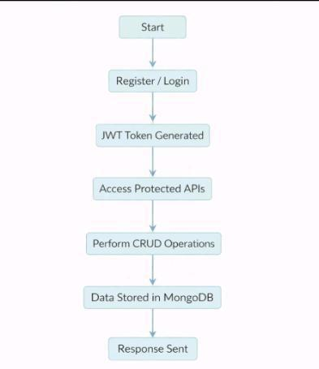

16. PROJECT SETUP AND CONFIGURATION:
1. Install required tools:
- Node.js
- MongoDB
2. Create project folders:
● server folders (models, routes, controllers, middleware, config)
3. Install Backend Packages:
- Express
- Mongoose
- Cors
- Jsonwebtoken
- Bcrypt
- Dotenv
17. BACKENED DEVELOPMENT:
- Setup Express server
- Create server.js file
- Create .env file and define PORT and DB UR
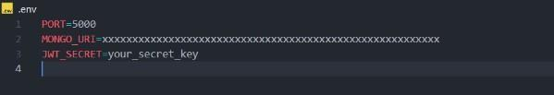

- Configure middleware (cors, express.json)

- User Authentication:
○ Create Register and Login routes
○ Generate JWT token
○ Protect routes using middleware
● Define API Routes:
○ Auth routes
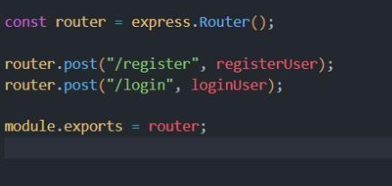

○ Transaction CRUD routes
● Implement Data Models
○ User schema
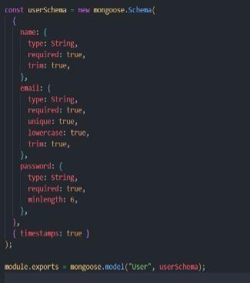
○ Transaction schema
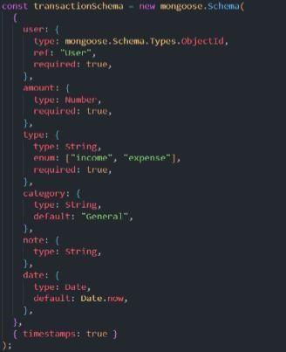

- Implement CRUD operations
- Add basic error handling

18. DATABASE DEVELOPMENT:
Configuration
  - Use MongoDB Atlas or a local MongoDB instance for the database.
  - Save the database connection URL in the .env file for security.
  - Establish the database connection using Mongoose
Create Database Connection MongoDB
  - Create a config file for DB connection
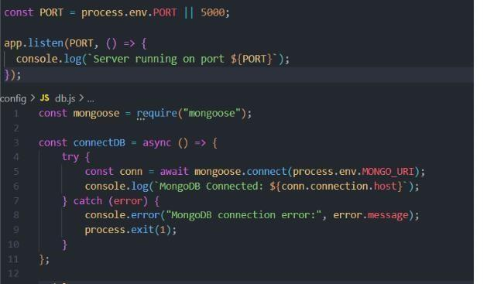
  - Use mongoose.connect()
  - Handle success and error cases
19. CREATE SCHEMA AND MODELS:
User Model
  - Name
  - Email
  - Password
Data / Transaction Model
  - User ID
  - Title / Description
  - Amount / Value
  - Timestamps

20. PROJECT EXECUTION:
Project Execution Steps:
- Start MongoDB
- Run backend server
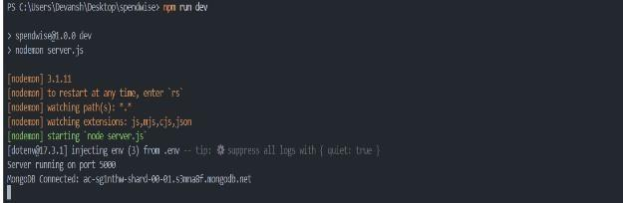
3.Test Register API
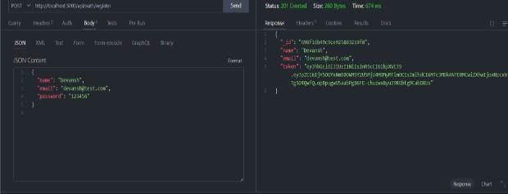
  - Test Login API
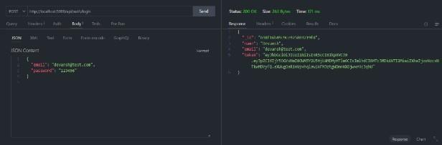
  - Copy JWT token
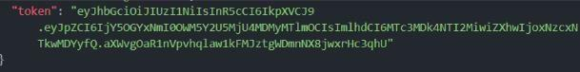
  - Use token to access protected CRUD APIs
  - Perform Create, Read, Update, Delete operations

21. OUTPUT SCREENSHOT:

1. Register API
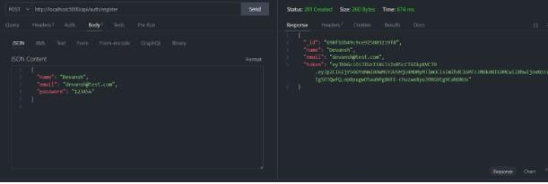

2.Login API
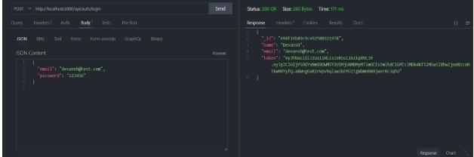
3.Create Transaction

4.Update API
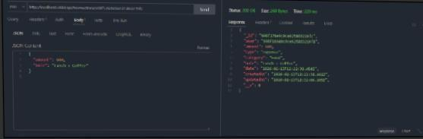
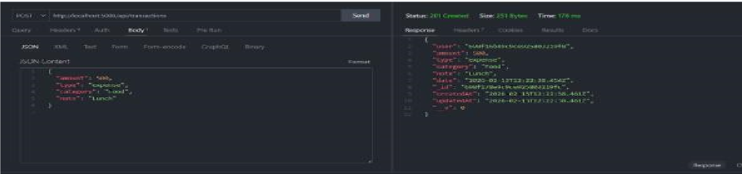

5.Delete API
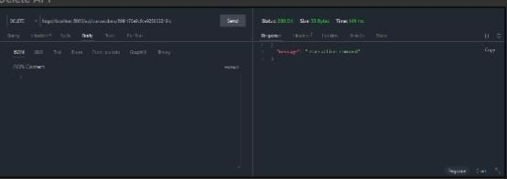

PROJECT DEMO VIDEO LINK: https://drive.google.com/file/d/1jVbsCAtjQTOMnNtljf1iXE4HrboFuyYj/view?usp=drive_link
PROJECT SOURCE CODE:
https://drive.google.com/drive/folders/1MTSSgFdHPV_1seSOjkHoYVLynxcE1VBb

